# How to Create the Layer Styles

**Step 1**

Open Photoshop, and go to File > New to create a new document.

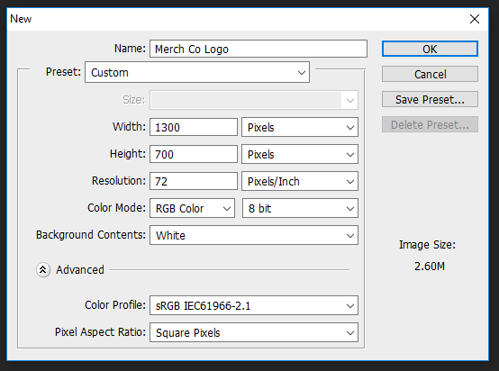

**Step 2**

Hold **ctrl** and press **A** (everything should now be highlighted)

Click **Edit** then **Fill** using the colour #282828

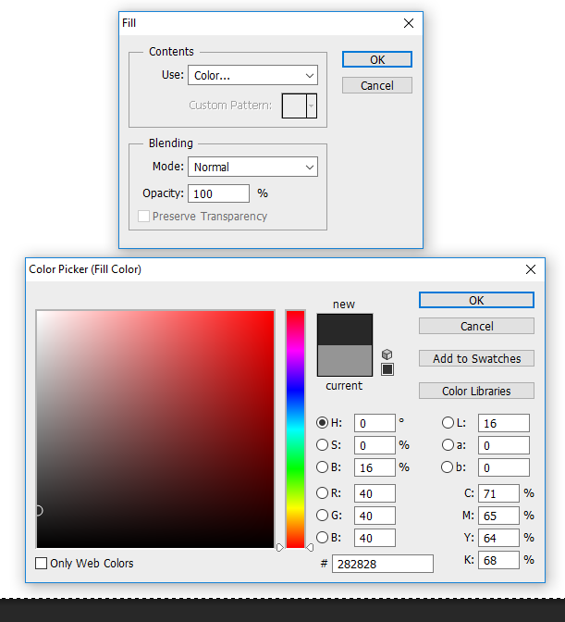

Pick the Type Tool (T) with these settings:

Font: (Your choice, I used **Copperplate Gothic Bold**)

Font Size: 127 pt

Color: White



Click the button at the far right in the image above and the menu below should appear.

For the **V/A** option, enter -25.

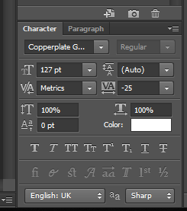

**Step 3**

Write **Your Company Name** (the first letter should be capital) and place it in the center of the Photoshop document (press Control-A to select the document, and then pick the Move Tool (V) and click on the Align Vertical Center and Align Horizontal Center icons). (These are the little bar icons next to “Show Transform Controls”.

You may want to shorten the name to fit on the screen if it doesn’t already. (Alternatively, you can click **Image** then **Canvas Size** and make the canvas wider.)

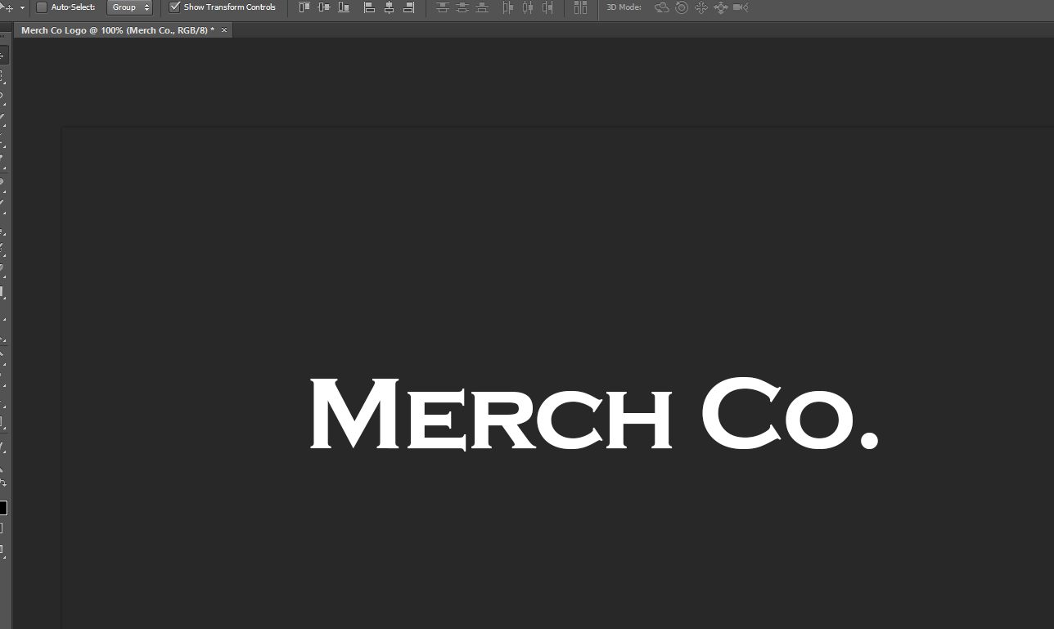

**Step 4**

Double-click the text layer to apply the following layer style.

Add a Stroke with these settings:

Size: 7 px

Position: Outside

Blend Mode: Normal

Opacity: 100%

Fill Type: Color

Color: **Your choice**

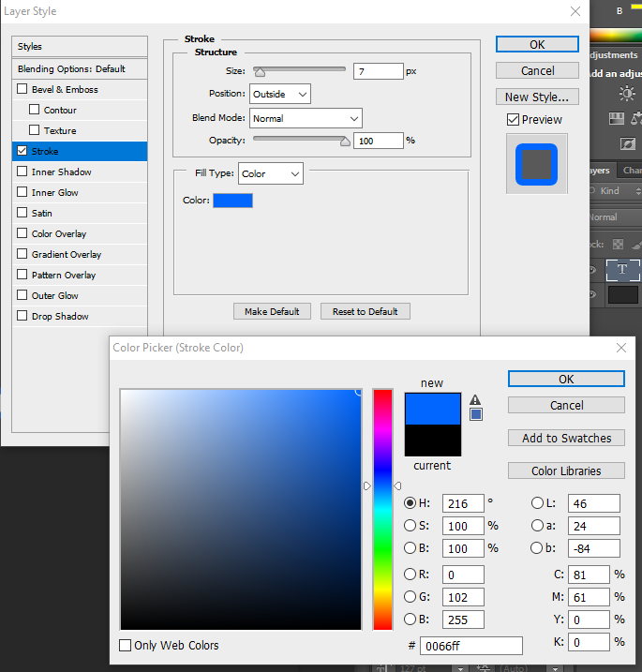

Then click OK to save the changes.

**Step 5**

Select the Text layer, go to Layer > Duplicate Layer, and name the layer "Middle".

Click OK to create the layer.

Pick the Move Tool (V) and move it up and left by 4 px. (Or whatever looks best for your chosen font.)

Go to Layer > Layer Style > Clear Layer Style to clear the layer styles.

Change the color to #c6c6c6 (grey).



**Step 6**

Then double-click on the new text layer to open the Layer Style window.

Add a Stroke with these settings:

Size: 4 px

Position: Outside

Blend Mode: Normal

Opacity: 100%

Fill Type: Color

Color: **Your choice** (Use a darker colour)

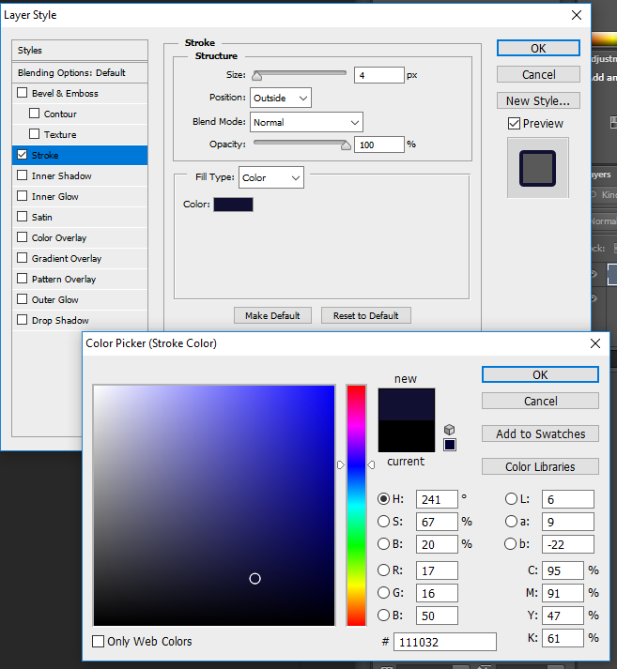

**Step 7**

Now add an Inner Glow:

Blend Mode: Overlay

Opacity: 50%

Noise: 0%

Color: #ffffff (white)

Technique: Softer

Source: Edge

Choke: 100%

Size: 4 px

Contour: Linear (The one where the bottom right corner is grey)

Uncheck Anti-aliased

Range: 100%

Jitter: 0%

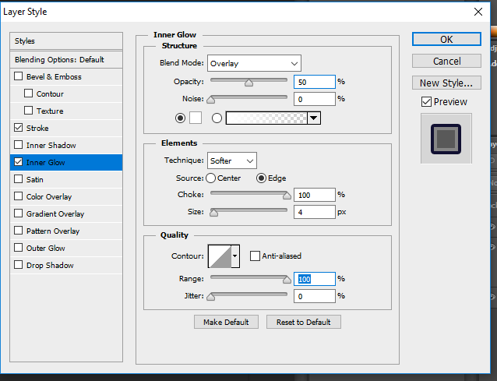

**Step 8**

Add a Gradient Overlay with these settings:

Blend Mode: Normal

Opacity: 100%

Gradient: from **a really light version of your main colour** to **a slightly darker colour**

Style: Reflected

Angle: 90°

Scale: 46%

Uncheck Reverse and Dither

Check Align with Layer

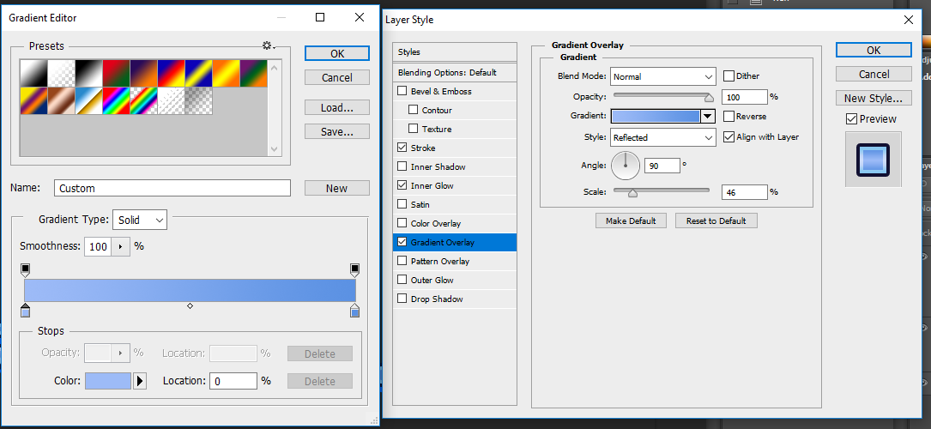

**Step 9**

Add a Drop Shadow with these settings:

Blending Mode: Normal

Pick the color: **A dark version of your main colour**

Opacity: 100%

Uncheck Use Global Light box

Set the Angle: 135°

Distance: 10 px

Spread: 100%

Size: 0 px

Contour: Linear

Uncheck Anti-aliased

Noise: 0%

Check Layer Knocks Out Drop Shadow

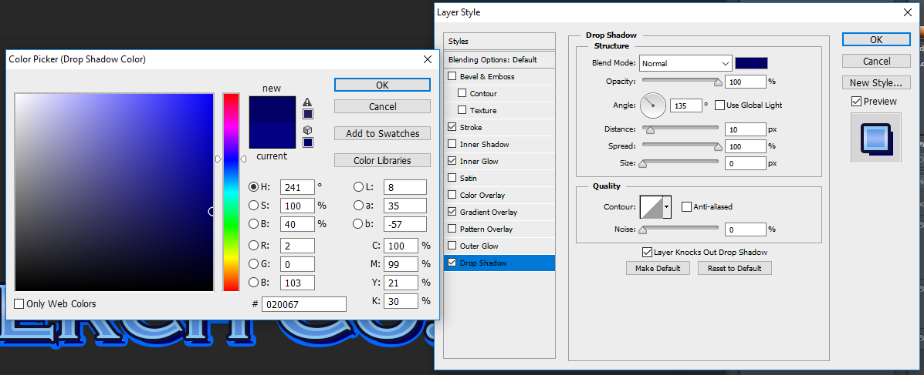

Click OK to save changes.

**Step 10**

Select the Middle layer and duplicate it.

Double-click on the name and change it to "Front".

Press Enter to apply the settings.

Pick the Move Tool (V) and move it up by 3 px and left by 1 px.

Go to Layer > Layer Style > Clear Layer Style to clear the layer styles.



**Step 11**

Make sure that the Front layer is selected.

Double-click on the layer to apply the following layer style.

Set the Fill Opacity to 0%.

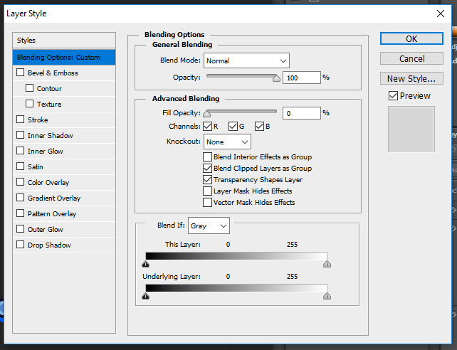

**Step 12**

Add a Stroke:

Size: 7 px

Position: Inside

Blend Mode: Normal

Opacity: 0%

Fill Type: Color

Color: #000000 (black)

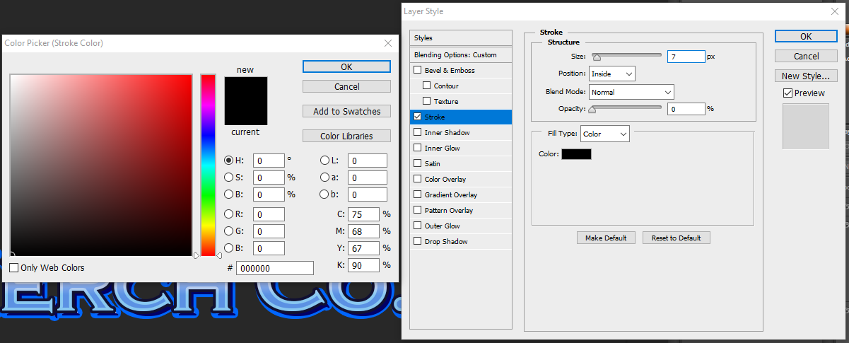

**Step 13**

Add a Color Overlay with these settings:

Blend Mode: Normal

Color: #ffffff (white)

Opacity: 40%

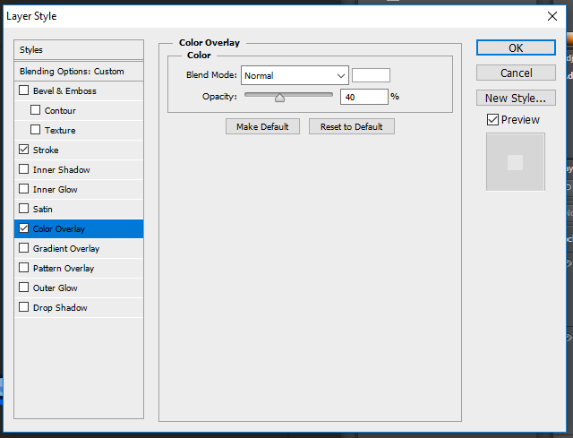

Then click OK to save changes.

**Step 14**

Select all three text layers, and go to Layer > Merge Layers (or press Control-E) to merge them into one.

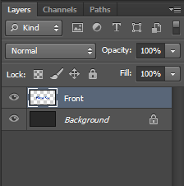

**Step 15**

Double-click the text layer to apply the following layer style.

Add a Stroke:

Size: 10 px

Position: Outside

Blend Mode: Normal

Opacity: 100%

Fill Type: Color

Color: #000000 (black)

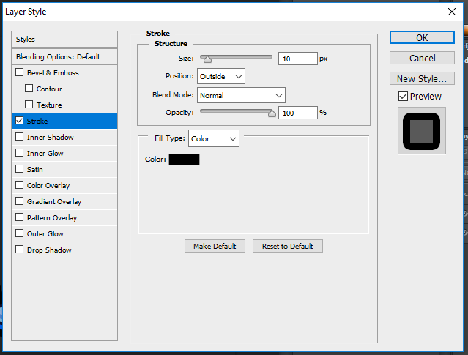

**Step 16**

Now add an Outer Glow:

Blend Mode: Normal

Opacity: 100%

Noise: 0%

Color: #ffffff (white)

Technique: Softer

Spread: 100%

Size: 14 px

Contour: Linear

Uncheck Anti-aliased

Range: 100%

Jitter: 0%

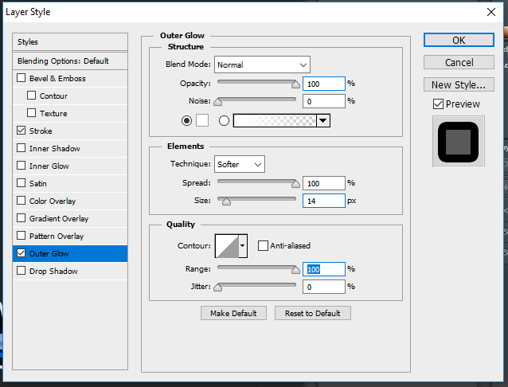

**Step 17**

Add a Drop Shadow with these settings:

Blending Mode: Normal

Pick the color: #000000 (black)

Opacity: 30%

Uncheck Use Global Light box

Set the Angle: 135°

Distance: 35 px

Spread: 0%

Size: 0 px

Contour: Linear

Uncheck Anti-aliased

Noise: 0%

Check Layer Knocks Out Drop Shadow

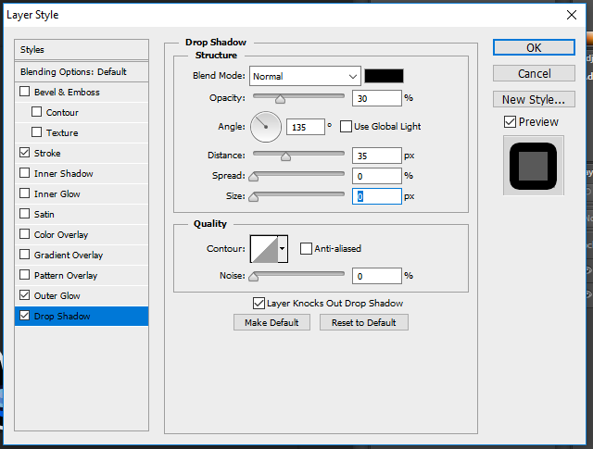

Click OK to save changes.

Congratulations, You're Done!

You should now be left with a logo that looks similar to this: (Depending on your font and text of course!)

Try changing the colours and the settings a little, see what else it can create!





